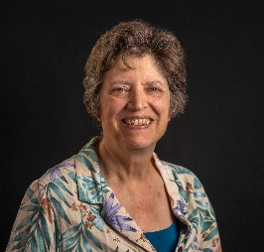
Rosi Gowdey Music Bio
March 2025
rgowdey.consulting@gmail.com

Rosi Gowdey warms her audiences with lyrics that tell stories we can relate to, melodies that make you want that ear worm, and a casual living room energy. She set down her accordion and picked up her first guitar in sixth grade. It was untuned, so she made up a tuning, and then made up chords so she could play along with Top 40 songs on the transistor radio. From there, she followed a breadcrumb trail behind Joan Baez that led into Appalachian traditional music, and eventually to the wider folk, blues, singer-songwriter world. By college, she was writing music for social change and to boost spirits, and performing at local open mics and coffeehouses, every progressive rally in Des Moines, and women’s music festivals across the country.
Her songwriting is a form of storytelling. “Soft Hills,” the title song on her 1987 cassette, is a love song to the women and land of her home, Iowa. “Woman in Change” has vivid documentary lyrics in the voice of women with children, who are in the throes of divorce. A humble tour eastward followed that release, and many midwestern solo concerts.
A move to Washington, D.C. brought a bit of exposure, a rewarding career in organizational leadership, and little time for music. Nonetheless, she joined melodic forces with four former professional musicians who happened to share an acupuncturist, forming Harmony Bones – four women, four styles, and great fun.
Rosi eventually set music aside, got a master’s degree, moved to Vermont, ran a marathon, took her job much too seriously, and in early 2024, picked up her instruments and her songwriting pencil with renewed vigor. As good fortune sometimes provides, her Vermont acupuncturist connected her with Sallie Mack. Sallie has done more than her part to keep the music scene of Vermont thriving through her own music and by helping to ensure other fine artists are heard. Together they are weaving their originals and covers together with harmonies, guitars and bass.
These days, you will hear a few of Rosi’s new originals, like the buoyant non-protest song, “Tonight Let’s Dance;” a haunting homage to those who have gone before called “Hummingbird;” and a tribute to her dad, “He Made Things.” They weave a diverse and adventuresome path alongside jazzy duets with Sallie and some good folk/Americana, and even rock and bluesy tunes. Audiences will be invited to sing along.

